Owner‘s Manual
2.4G WIRELESS
DMX SPLITTER 4

Thank you for choosing one of our DMX splitters. Please read this user manual carefully and follow the instructions to avoid danger or damage to the unit due to mishandling. Keep this user guide for future reference. Please carefully read the instruction, which includes important information about the installation, usage and maintenance, BEFORE operating this device.
*This device is exclusively meant to be used as a splitter for DMX signals within the limits given in this manual. Using it in any other way you risk electric shock and warranty will become void.
*Never sever or manipulate the power cord or the plug. If a power cord is provided with an earth lead, this is mandatory to ensure safe operation! Otherwise a LIFE THREATENING situation exists!
*Unpack and check carefully there is no transportation damage before using the unit. Never put a damaged device into operation.
*Before operating, ensure that the voltage and frequency of power supply match the power requirements of the unit as stated in this manual.
*The unit is for indoor use only. Use it only in a dry location. Exposing the device to rain or moisture would cause the risk of electrical shock or fire.
*DO NOT let any liquids or objects enter the unit. Should any liquid be spilled on the unit, DISCONNECT the power supply to the unit immediately and contact the service company.
*The unit must only be installed in a location with adequate ventilation. Be sure that no ventilation slots are blocked. In order to guarantee adequate ventilation, allow a free air space of at least 20 cm around the sides and top of the unit.
*Disconnect the device from the mains power before any servicing or maintenance.
Notice regarding power disconnection: To disconnect the device from the power source the power plug must be removed from the power socket. For this reason the device must be placed in a position where a constant unobstructed access to the power socket is assured, thus in an emergency situation you are able to immediately pull out the power plug. To eliminate the risk of fire you must completely disconnect the power plug from the power socket after the device has been used.
*Always grasp the power cord by the plug. Do not pull on the cord itself and never touch the power cord with wet hands as this could result in a short circuit or an electrical shock. Do not place the device, speaker cabinets or anything else on the power cord and make sure that it does not become clamped. Place the power cord in a position where it can not be trod on. A damaged power cord can cause a fire or an electrical shock. Check the power cord from time to time. Should it become damaged contact our customer service centre to have it replaced.
*You have to ensure, that the power cord never becomes wet during operation.
*Before a storm and/or a thunderstorm with a risk of lightning, disconnect the device from the mains power supply.
*Under no circumstances may you open the device housing. Should you do so your safety would not be assured. There are no operational components whatsoever inside, only dangerous voltages that can give you a deadly shock!
*NEVER use the unit under the following conditions :> In places subject to vibrations or bumps.> In places with a temperature of over 45 °C or less than 2 °C.> In places subject to excessive dryness or humidity (ideal conditions are between 35% and 80%).
*Never submerse the device in water or any other liquid. Only wipe it with a slightly damp cloth.
*Never operate the device near flames, flammable, explosive materials, or hot surfaces. Otherwise you run the risk of causing a fire.
*Never leave this device running unattended.
*This appliance must not be used by individuals (including children) with restricted physical, physiological or intellectual abilities or deficiencies in experience and/or knowledge unless they are supervised by a person responsible for their safety or receive from this person instruction in how the appliance is to be used.
*Keep children away from the device and power cord! Children frequently underestimate the dangers of electrical devices. Also keep the plastic packaging well away from small children. There is a risk of suffocation!
*In the event of serious operating problems, stop using the unit immediately. Never try to dismantle, repair or modify the unit by yourself. Otherwise warranty becomes void. Repairs carried out by unskilled people can lead to damage or malfunction. Please contact the nearest authorized technical assistance centre.
The DMX distributor offers one wireless input and four outputs. Both inputs and outputs as well as outputs among each other are completely eclectically isolated. Each DMX output features an independent driver and DATA+ & DATA- indicator. Using the built-in switch you can easily terminate the LINK OUT, when you don’t want to transmit the DMX signal to other units.
Power supply voltage : AC 90-230 V~, 50 Hz
Fuse (internal) F 500 mA, 250 V

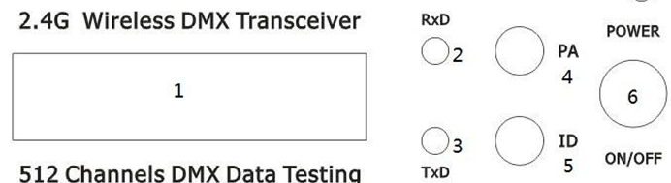
1 ：L C D d isp lay
2 ：Ind ica to r light o f rece iver
3 ：Indicator light of transmitter
4 ： S e ttin g k no b o f transmittin g po w e r ra te
5 ：ID O p tio n K no b
6 ：P o w e r S w itch
< N O T E : W h en the R & T is w e ll con ne c ted . R ed & B lue L E D w ill flash w ith fas t spee d .>
Establishing Communication ：

  - .P o w e r on
  - .Press “PA ” to s e t tran s m itting po w e r ra te v a lu e ， then press “ID” to s e t the rec e iv e r / tran s m itte r w ith s a m e ID . P lea s e p a y m o re a tten tion , it is ve ry im po rtan t to s e t d iffe ren t ID v a lu e fo r d iffe ren t g rou p o f W ire les s ne t.
  - T h is eq u ip m en t s ta rt to c h oo s e n on -in te rfe re freq ue n c y s ec tio n fo r tran s m itting s ign a l da ta a fte r rec e ive d D M X s ig na l da ta ，rec e iv e r s ta rt to c ha ng e c o m m un ic a te freq u e nc y s ec tion ，the n Ind ic a to r lig h ts o f rec e ive r an d tra ns m itte r w ill flas h a t s a m e tim e , till
rec e iv ed c o rrec t ID v a lu e .
  - . D one
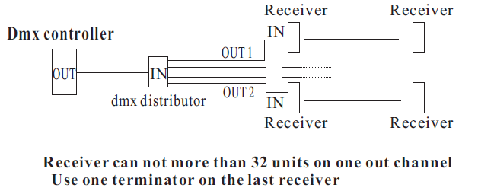
DMX OUT: connect the DMX receiving device(s) here
DMX IN: connect the DMX transmitting device here
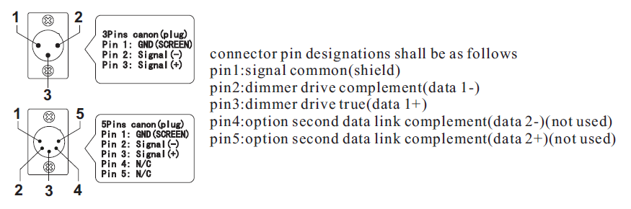
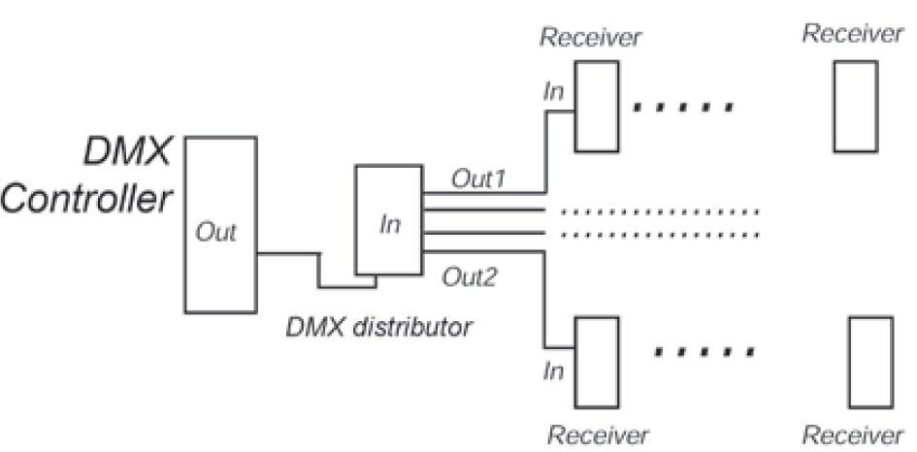
You can run a maximum of 32 units (receiver) per output channel.
Use a terminator on the last receiver.
If you don’t connect other units to the DMX LINK OUT socket, you have to press the switch underneath the socket, to terminate this output.
You may only connect the device to a properly wired and earthed mains power wall outlet, after all DMX connections have been established. The wall outlet must provide the correct mains voltage as stated in this manual.

